Unit 7

BIG DATA

7.1 Introduction
Big Data refers the massive volume of structured and unstructured data that is generated by individuals, organizations, and devices. Big data is larger, more complex data sets, especially from new data sources. These data sets are so voluminous that traditional data processing software just can’t manage them. But these massive volumes of data can be used to address business problems you wouldn’t have been able to tackle before. This data is too large and complex to be processed and analyzed using traditional data processing tools. The term "big data" often refers to the use of advanced technologies and techniques, such as cloud computing, machine learning, and artificial intelligence, to extract meaningful insights and value from this data. Big data is data that contains greater variety, arriving in increasing volumes and with more velocity. This is also known as the three V’s.
Some of the main reasons for the need of big data are:
- Improved decision making: Big data allows organizations to gain insights into patterns and relationships in their data, which can lead to better decision making and improved business outcomes.
- Increased efficiency: Big data can be used to automate and optimize processes, reducing costs and increasing efficiency.
- Customer insights: Companies use big data to gain a deeper understanding of their customers, allowing them to improve customer experience and increase sales.
- Competitive advantage: Organizations that leverage big data insights can gain a competitive advantage over their competitors.
- New business opportunities: Big data can help organizations identify new business opportunities and revenue streams.

Applications of big data include:
- Customer analytics: Companies use big data to gain insights into customer behavior, preferences, and purchase patterns, helping them to improve customer experience and increase sales.
- Fraud detection: Big data is used to identify and prevent fraudulent activities in industries such as finance and insurance.
- Predictive maintenance: Companies in industries such as manufacturing and transportation use big data to predict and prevent equipment failures, reducing downtime and maintenance costs.
- Healthcare: Big data is being used to improve patient outcomes and reduce healthcare costs by analyzing patient data and identifying patterns in diseases and treatments.
- Social Media Analytics: Big data is used to analyze social media data and gain insights into consumer opinions, preferences, and behaviors.
- Marketing: Big data is used to improve marketing strategies by analyzing customer data and identifying target audiences.

7.2 Characteristics of Big Data
The first three characteristics of big data are volume, velocity, and variety. Additional characteristics of big data are variability, veracity, Variety Value, Validity, Volatility and Visualization.
1. Volume
Volume refers to the amount of data that you have. We measure the volume of our data in Gigabytes, Zettabytes (ZB), and Yottabytes (YB). According to the industry trends, the volume of data will rise substantially in the coming years. This can be data of unknown value, such as Twitter data feeds, clickstreams on a web page or a mobile app, or sensor-enabled equipment.
2. Velocity
Velocity refers to the speed of data processing. High velocity is crucial for the performance of any big data process. It consists of the rate of change, activity bursts, and the linking of incoming data sets. Some internet-enabled smart products operate in real time or near real time and will require real-time evaluation and action.
3. Variety
Variety refers to the different types of big data. It is among the biggest issues faced by the big data industry as it affects performance. It’s vital to manage the variety of your data properly by organizing it. Variety is the various types of data that you gather from different kinds of sources.
4. Value
Value refers to the benefits that your organization derives from the data. Does it match your organization’s goals? Does it help your organization enhance itself? It’s among the most important big data core characteristics.
5. Veracity
Veracity refers to the accuracy of your data. It is among the most important Big Data characteristics as low veracity can greatly damage the accuracy of your results.
6. Validity
How valid and relevant is the data to be used for the intended purpose.
7. Volatility
Big data is constantly changing. The data you gathered from a source a day ago might be different from what you found today. This is called variability of data, and it affects your data homogenization.
8. Visualization
Visualization refers to showing your big data-generated insights through visual representations such as charts and graphs. It has become prevalent recently as big data professionals regularly share their insights with non-technical audiences.

7.3 Challenges of Big Data
Many companies get stuck at the initial stage of their Big Data projects. This is because they are neither aware of the challenges of Big Data nor are equipped to tackle those challenges. The challenges of conventional systems in Big Data need to be addressed.
Below are some of the major Big Data challenges and their solutions.
1. Lack of proper understanding of Big Data
Companies fail in their Big Data initiatives (the ability to assess) due to insufficient understanding. Employees may not know what data is, its storage, processing, importance, and sources. Data professionals may know what is going on, but others may not have a clear picture.
For example: if employees do not understand the importance of data storage, they might not keep the backup of sensitive data. They might not use databases properly for storage. As a result, when this important data is required, it cannot be retrieved easily.
Solution
Big Data workshops and seminars (basically meeting) must be held at companies for everyone. Basic training programs must be arranged for all the employees who are handling data regularly and are a part of the Big Data projects.
2. Data growth issues
One of the most pressing challenges of Big Data is storing all these huge sets of data properly. The amount of data being stored in data centers and databases of companies is increasing rapidly. As these data sets grow exponentially with time, it gets extremely difficult to handle. Most of the data is unstructured and comes from documents, videos, audios, text files and other sources. This means that you cannot find them in databases. This can pose huge Big Data analytics challenges and must be resolved as soon as possible, or it can delay the growth of the company.
Solution
In order to handle these large data sets, companies are opting for modern techniques, such as compression, tiering, and de-duplication. Compression is used for reducing the number of bits in the data, thus reducing its overall size. De-duplication is the process of removing duplicate and unwanted data from a data set. Companies are also opting for Big Data tools, such as Hadoop, NoSQL and other technologies.
3. Confusion while Big Data tool selection
Companies often get confused while selecting the best tool for Big Data analysis and storage. Is Hbase (non-relational database & stored in stored in individual columns) or Cassandra the best technology for data storage? Is Hadoop Map Reduce good enough or will Spark be a better option for data analytics and storage? These questions bother companies and sometimes they are unable to find the answers. They end up making poor decisions and selecting inappropriate technology. As a result, money, time, efforts and work hours are wasted.
Solution
The best way to go about it is to seek professional help. You can either hire experienced professionals who know much more about these tools. Another way is to go for Big Data consulting. Here, consultants will give a recommendation of the best tools, based on your company’s scenario. Based on their advice, you can work out a strategy and then select the best tool for you.
4. Lack of data professionals
To run these modern technologies and Big Data tools, companies need skilled data professionals. These professionals will include data scientists, data analysts and data engineers who are experienced in working with the tools and making sense out of huge data sets. Companies face a problem of lack of Big Data professionals. This is because data handling tools have evolved rapidly, but in most cases, the professionals have not.
Solution
Companies are investing more money in the recruitment of skilled professionals. But, important step taken by organizations is the purchase of data analytics solutions that are powered by artificial intelligence/machine learning. These tools can be run by professionals who are not data science experts but have basic knowledge. This step helps companies to save a lot of money for recruitment.
5. Securing data
Securing these huge sets of data is one of the daunting challenges of Big Data. Often companies are so busy in understanding, storing and analyzing their data sets that they push data security for later stages. But, this is not a smart move as unprotected data repositories (warehouse) can become breeding grounds for malicious hackers.
Solution
Companies are recruiting more cyber security professionals to protect their data. Other steps taken for securing data include:
- Data encryption
- Identity and access control
- Implementation of endpoint security
- Real-time security monitoring
- Use Big Data security tools, such as IBM Guardian
6. Integrating data from a variety of sources
Data in an organization comes from a variety of sources, such as social media pages, ERP(Enteprise Resource Planning) applications, customer logs, financial reports, e-mails, presentations and reports created by employees. Combining all this data to prepare reports is a challenging task. This is an area often neglected by firms. But, data integration is crucial for analysis, reporting and business intelligence, so it has to be perfect.
Solution
Companies have to solve their data integration problems by purchasing the right tools. Some of the best data integration tools are mentioned below:
- Talend Data Integration
- Centerprise Data Integrator
- ArcESB
- IBM InfoSphere
- Xplenty
- Informatica PowerCenter
- CloverDX
- Microsoft SQL
- QlikView
- Oracle Data Service Integrator

7.4 Advantages of Big data
The advantages of big data are as follow:
1. Customer Acquisition (gaining) and Retention (holding)
The digital footprints of customers reveal a lot about their preferences, needs, purchase behavior, etc. Businesses use big data to observe consumer patterns and then tailor their products and services according to specific customer needs. This goes a long way to ensure customer satisfaction, loyalty, and ultimately a considerable boost in sales.
Amazon has utilized this big data benefit by offering the ultimate personalized shopping experience, wherein suggestions pop up based on previous purchases as well as products that other customers have bought, browsing patterns, and other factors.
2. Focused and Targeted Promotions
Big data allows businesses to deliver customized products to their targeted market—no more spending fortunes on promotional campaigns that do not deliver. With big data, enterprises can analyze customer trends by monitoring online shopping and point-of-sale transactions. These insights are then used to design-focused and targeted campaigns that help brands live up to customer expectations and build brand loyalty.
3. Potential Risks Identification
Businesses function in high-risk environments, so they require effective risk management solutions to address issues. Big data plays a critical role in developing effective risk management processes and strategies. Big data analytics and tools promptly reduce risks by optimizing complex decisions for unexpected events and potential threats.
4. Innovate
The insights you gain using big data analytics are the key to innovation. Big data allows you to update existing products/services while innovating new ones. The large volume of data collected helps businesses identify what fits their customer base. Information on what others think of your products/services can help in product development. The insights can also be used to twist business strategies, improve marketing techniques, and optimize customer service, employee productivity.
In today's competitive market space, it is necessary for businesses to implement processes that help track customer reviews, the success of products, and monitor competitors. Big data analytics facilitates real-time tracking of the market and keeps you ahead of competitors.
5. Cost optimization
One of the most compelling benefits that big data tools like Hadoop and Spark offer include significant cost advantages for storing, processing, and analyzing large volumes of data. The cost reduction benefit of big data is appropriately demonstrated through an instance from the logistics industry.
Typically, the cost of returns is 1.5 times higher than normal shipping costs. Companies use big data and analytics to minimize product return costs by calculating the chances of product returns. Thus they can take suitable measures to minimize product-return losses.
6. Improve Efficiency
Big data tools can improve operational efficiency—your interaction with customers and their valued feedback help to collect large amounts of valuable customer data. Analytics can then extract meaningful patterns hidden within the data to create customized products. The tools can automate routine processes and tasks, thereby freeing up valuable time for employees, which they can utilize to perform tasks requiring cognitive skills.

7.5 Types of Big data
Big data types in Big Data are used to categorize the numerous kinds of data generated daily. Primarily there are 3 types of data in analytics. The following types of Big Data with examples are explained below:-
1. Structured Data: Any data that can be processed, is easily accessible, and can be stored in a fixed format is called structured data. In Big Data, structured data is the easiest to work with because it has highly coordinated measurements that are defined by setting parameters. Structured types of Big Data are:-
- Address
- Age
- Credit/debit card numbers
- Contact
- Expenses
- Billing
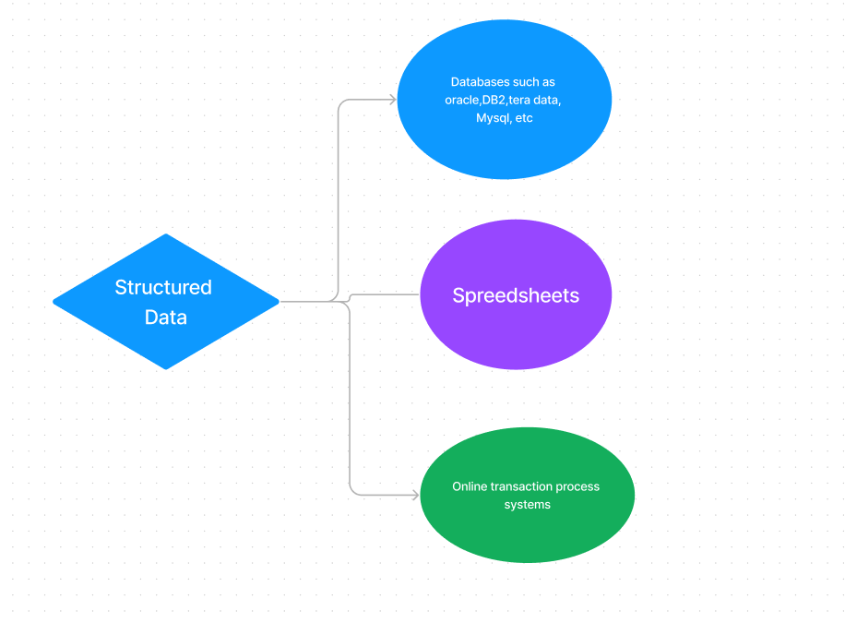
2. Unstructured Data: Unstructured data in Big Data is where the data format constitutes multitudes of unstructured files (images, audio, log, and video). This form of data is classified as intricate data because of its unfamiliar structure and relatively huge size. A stark example of unstructured data is an output returned by ‘Google Search’ or ‘Yahoo Search.’
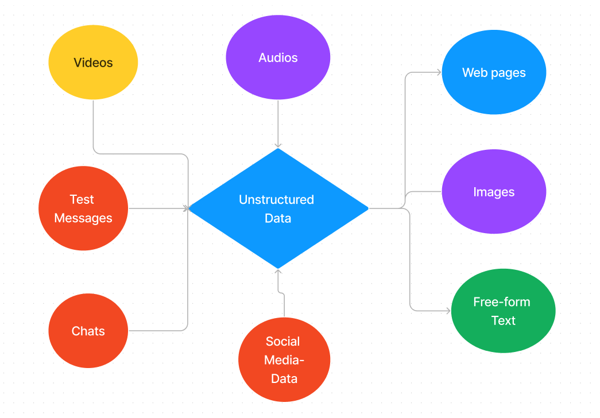
3. Semi-structured Data: In Big Data, semi-structured data is a combination of both unstructured and structured types of data. This form of data constitutes the features of structured data but has unstructured information that does not adhere to any formal structure of data models or any relational database. Some semi-structured data examples include XML and JSON.

Subtypes of Data
This form of data does not typically fall under the umbrella of Big Data. However, certain subtypes of data are relevant in the field of analytics. This type of data often refers to the origin of data. They are classified as follows:-
- Machine (operational logging)
- Social media or event-triggered
- Geospatial (locational)

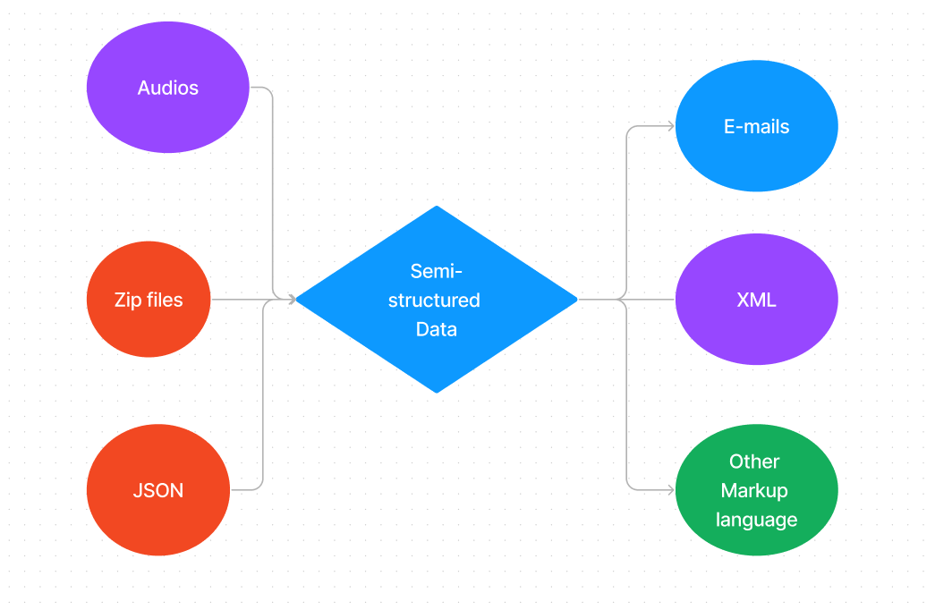

7.6 Example of big data
Big Data usage has grown to the point where it touches nearly every aspect of our lifestyles, shopping habits, and routine consumer choices.
Here are some examples of Big Data applications that affect people every day.
1. Big Data in the Airline Industry
Airlines collect a large volume of data that results from categories like customer flight preferences, traffic control, baggage handling and aircraft maintenance. Airlines can optimize operations with the meaningful insights of big data analytics. This includes everything from flight paths to which aircraft to fly on what routes.

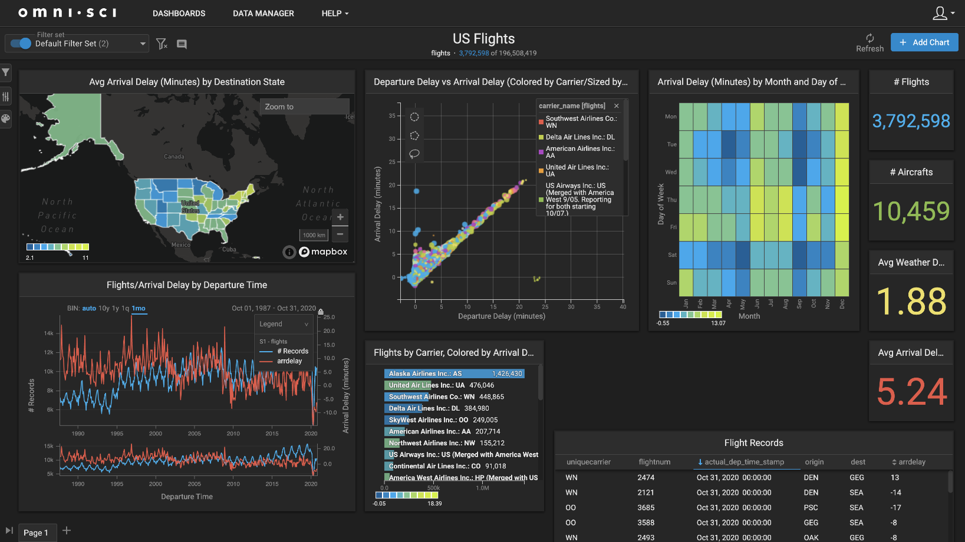
FIG: Example of Big data visualization of US airlines
2. Big Data Analytics Banking
Big data search analytics helps banks make better financial decisions by providing insights to massive amounts of unstructured data. The information is available and analyzed when it’s most needed. The process avoids reliance on overlapping systems. It also focuses on fraud detection using big data analytics.
3. Big Data in Government
Government agencies face a constant pressure to do more with less resources. Public safety agencies are expected to combat crime and budgets do not always rise in conjunction with crime rates. Big data analytics allows law enforcement to work smarter and more efficiently. It is also used for combating census undercount. And it allows any government agency to streamline operations and better target resources for maximum results.
4. Big Data Analytics in Healthcare
The volume of patient, clinical and insurance records in healthcare generates mountains of data. Data analytics lets hospitals get important insights out of what would have been an unmanageable amount of data. The ability to extract useful information out of structured and unstructured data can lead to better outcomes in patient treatment and organizational efficiency.
5. Big Data in Retail
With big data analytics, retailers are able to understand customer behavior and preferences better than ever before. Transaction data based on buying habits allows retailers to cater to specific customer demands. Advanced analytics of customers gives retailers the ability to predict trends and create more profitable products.
‍6. Big Data Analytics in Education
Today, big data helps educators go far beyond keeping A's, B's and C's in a book, tracking information across schools, districts, and states such as performance, background, behavior and emotional learning. By collecting big data from many channels, educators can use tools for big data analytics to develop personalized education goals and plans based on student performance on assignments and tests. Big data also helps educators gain student attention and track performance to provide personalized feedback. By customizing approaches and programs, schools and educators can minimize attrition and maximize results using big data analytics.
7. Big Data Analytics in Sports
Big Data enables sports companies and teams to make better predictions, remain up to date on performance, and stay on course while in play. Results are what moves the professional sports industry, and they are only achievable with detailed, pooled data on player performance, stats, and comprehensive skills. For example, Liverpool FC has successfully dominated rivals with data science in recent years, with data science influencing Liverpool coaching decisions in real-time.

7.7 Introduction to Hadoop
Hadoop is an open source, Java based framework used for storing and processing big data. The data is stored on inexpensive commodity servers that run as clusters. Its distributed file system enables concurrent processing and fault tolerance. Developed by Doug Cutting and Michael J. Cafarella, Hadoop uses the MapReduce programming model for faster storage and retrieval of data from its nodes. The framework is managed by Apache Software Foundation and is licensed under the Apache License 2.0.
For years, databases have lagged behind due to their limited capacity and speed. However, today, as many applications are generating big data to be processed, Hadoop plays a significant role in providing a much-needed makeover to the database world. Additionally, Hadoop has ability to collect massive data, and the insights derived from crunching this data, results in better business decisions in the real-world, such as the ability to focus on the right consumer segment, optimize floor operations, provide relevant search results, perform predictive analytics, and so on.
Here’s a brief sample of successful Hadoop users:
- British Airways
- Uber
- The Bank of Scotland
- Netflix
- The National Security Agency (NSA), of the United States
- The UK’s Royal Mail system
- Expedia
- Twitter
It is the most commonly used software to handle Big Data. There are three components of Hadoop.
- Hadoop HDFS - Hadoop Distributed File System (HDFS) is the storage unit of Hadoop.
- Hadoop MapReduce - Hadoop MapReduce is the processing unit of Hadoop.
- Hadoop YARN - Hadoop YARN is a resource management unit of Hadoop.
Advantages of Hadoop for Big Data
- Speed. Hadoop’s concurrent processing, MapReduce model, and HDFS lets users run complex queries in just a few seconds.
- Diversity. Hadoop’s HDFS can store different data formats, like structured, semi-structured, and unstructured.
- Cost-Effective. Hadoop is an open-source data framework.
- Scalable. Since Hadoop functions in a distributed environment, you can easily add more servers.

